Chocolate Pie Filling

Ingredients

- 1-1/4 cup of sugar
- 1/2 cup of plain flour
- 1/4 cup of cocoa
- dash of salt
- 4 egg yolks
- 2 cups of milk
- 1/4 cup of butter
- 1 tsp of vanilla
- 1-9" pastry shell baked

Directions
- 1-2 people work on the pie crust recipe
- Combine first 4 ingredients (from this page) in a sauce pan; set aside.
- Separate the egg yolks and the egg whites. The Meringue person takes the egg whites and makes the meringue. Chocolate filling people proceed below.
- Combine milk and egg yolks.
- Stir milk and egg yolks into mixture; add butter.
- Cook over medium heat, and stir constantly until mix thickens and boils.
- Remove from heat; stir in vanilla; spoon into pastry shell.
- Put meringue on top and broil for 2 min or until golden brown on top. Watch carefully it will burn quick.

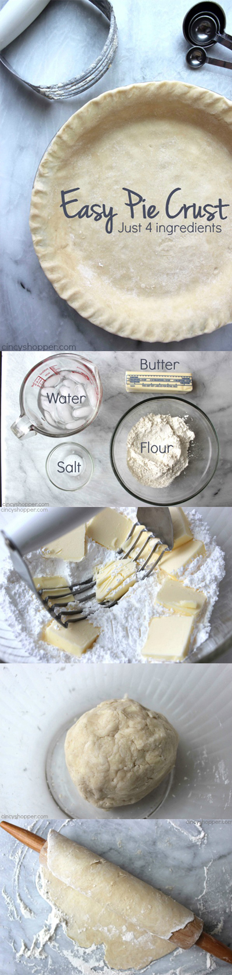
Easy Pie Crust
Ingredients
- 1 cup Flour
- 1/2 tsp Salt
- 6 tbsp cold Butter
- 4 tbsp ice cold Water
Instructions
- Mix together flour and salt in medium sized bowl.
- Cut in butter with pastry blender or forks until mixture is
pebble sized crumbs.
- Add water and blend until mixture pulls together.
- Roll into ball and place on lightly floured surface.
If there is time let the dough rest in fridge for 20-30 min.
- Preheat oven to 350 degrees.
- Roll out dough to about 13" circle.
- Gently roll dough around rolling pin and unroll over pie
pan.
- Gently press into pan and turn edge under.
- Crimp edges (Pinch with your fingers into a
decorative pattern)
- Pierce the bottom of the pie crust with a fork and bake
Until golden brown 10-15 minutes at 350 degrees.

Meringue

- 4 Egg Whites
- 6 Tablespoons of White Sugar
- The first thing you need to do is carefully separate the egg yolks from the egg whites. It is very important that you don’t get any of the yolk into the egg whites or it won’t set up properly.
- Begin to whip your egg whites until they look like foam.
- Next with your mixer, gradually add in the sugar one tablespoon at a time.
- Beat the sugar into the egg mixture until it forms stiff white peaks. I normally have to mix my eggs for a couple of minutes total. It should look like cool whip, and the peak like Jimmy Neutrons hair or the top of Dairy Queens ice cream.
- After your meringue is nice and thick pour it on top of your pie and spread evenly on the pie slightly covering the crust. With a spoon make peaks with the meringue on your pie.
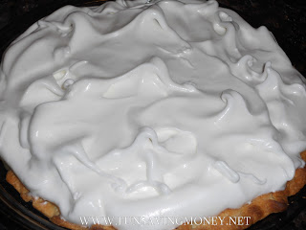
- Broil 2-3 minutes or bake at 350 degrees for 5-8 minutes until golden brown. Remove and cool. Refrigerate 8 hours or overnight.

CLEAN UP-Everyone!
•return all ingredients to storage
•wipe down counters and sanitize
•wash all equipment in hot, soapy water including the microwave and hood of the range (stovetop)
•rinse equipment
•sanitize equipment and place dry
•sweep floor
•place used towels and dishcloths in laundry basket
•return apron to dirty apron basket

