Welcome to Foods!

Lauren Engelhardt Email: lauren.engelhardt@lz95.org

FACS Office: B136 Office Phone: 847-540-4611

COURSE DESCRIPTION
Introduction to Foods is a one semester course designed to give the students an overview of cooking basics. The course offers students the opportunity to explore and develop abilities in food preparation, nutrition, cutting techniques, food and kitchen safety, and proper foods lab procedures. The course material will be studied in a lecture, project, activity-oriented, and laboratory environment.

OBJECTIVES:
The overall goals of this course are to help you to be a wise, informed food consumer and to help you prepare high quality BASIC food products. As a result of the experiences of this class, you will be able to demonstrate:

1. Basic knowledge of culinary techniques, including the identification and appropriate use of basic food preparation equipment and food preparation terminology.
2. A working knowledge of food safety and sanitation through the use of preparation and storage procedures to ensure food safety.
3. The ability to apply food science knowledge to the functions of ingredients.
4. The ability to prepare and formally present basic food products as served in the home environment.
5. A better understanding of nutrition, the food guide pyramid, and the six nutrients, their uses and food sources.

STUDENT EXPECTATIONS:
- Respect for the teacher, peers and for themselves!!!
- NO cell phones or electronics unless allowed by teacher for specific academic research. There will be a warning first, and then the second time the phone/electronic will be taken until the end of the period!
- Students will be expected to participate in class discussions
- A variety of assignments will be completed during class time
- Homework assignments will be turned in on time for full credit. The grade will drop 10% for each day late.
- For each day of excused absences, students will have one day to turn in make-up work.

- All make up work can be found in the missed work bin! Find what day you missed on the class calendar then find your work by looking in the folder with the corresponding number. You will have one week to complete any missed work in order to receive full credit!
- Students are to work cooperatively in groups.
- Evaluations of food products must be completed on the day of the lab.
- Students are to clean their labs prior to leaving the classroom and be signed off by the teacher. Failure to meet this requirement will result in a zero for the day for that particular group.
Topics to be covered: (Including, but not limited to):

Safety & Sanitation
Quick Breads
Yeast Breads
Pasta
Vegetables
Fruits
Pies/ Pastries
Cookies
Gingerbread Houses (Fall)
Appetizers
Nutrition
Storage
Food Labels
Recipe Conversions
Table Settings
Food Allergies/ Special Diets

EVALUATION:
Your grade will be made up of the following:

- Homework
- Labs
- Class work and participation
- Tests/Quizzes
- Final exam will be worth 20% of the final semester grade

Grading Scale: The grading scale for this class is as follows. Remember, you earn the grade you receive. Every point counts so be sure to do your best throughout the semester.
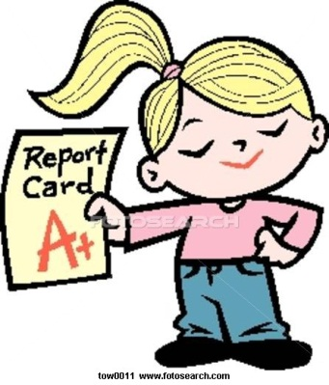
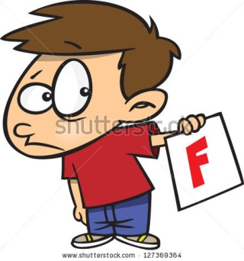
100% - 90% = A
89.9% - 80% = B
79.9% - 70% = C
69.9% - 60% = D
59.9% - 0% = F

Each quarter will be worth 40% of your semester grade & the final examination will be worth 20% of your overall grade.

Jail ‘Cell’ System:
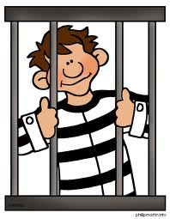
If you are using your cell phone/iPad in class for reasons other than school work, your technology will find itself locked away in our classroom’s jail ‘cell’. The student will then be issued a ticket with the ‘bond’ price in the form of a chore that must be completed in order to set your cell phone free by the end of class. ‘Bond’ prices vary from class to class depending on what is being done that day and how many offences you have had. For example, your cell phone’s bond may include a form of cleaning, folding, organizing, etc. On a student’s 3rd offence, their cell phone will be placed in contempt and they must go on trial with the Dean’s office.

LAB ATTIRE:
While cooking, long sleeves must be rolled up, hair tied back, and hoods removed. Students will also wear appropriate aprons as per your teacher’s colored apron system.

Attendance and Lab Make Up Policy:
If a student is absent the day of a cooking lab, it is fully their responsibility to make up the foods lab at home or during a lab make up appointment time (scheduled with teacher on individual basis). To make up a lab, a student will have to follow the rules of the lab make up form. This form can be found on Ms. Engelhardt’s school website under “Foods Lab Make Up Form”.

For full lab make up credit:
- Recipe must be from scratch; no mixes, convenience foods or boxed foods accepted. All recipes are posted on the teacher’s school website.
- Write entire recipe on the backside of make-up form if the recipe was not one prepared in class.
- Attach, or show me on a cell phone, at least 3 pictures of you making the recipe in your kitchen. At least 1 picture needs to show the final product!
- A parent or guardian must fill out the table and sign the make-up form.
- You need to fill out the post lab make up questions document
- The completed forms, and pictures, must be brought to the teacher within one week of absence.

Foods Room Pledge

I pledge: that in the Lake Zurich Foods Room, I will be respectful of the rules and procedures given to me. I know that taking this class comes with a lot of responsibility and the need to keep myself and others safe. The environment of a foods lab can be challenging, but I promise to stay on task and not be a distraction to others around me. I also am FULLY aware that cooking food in a lab is a PRIVELAGE and that it can be taken away from me at any time. If I choose not to follow classroom rules and safety procedures, I will be asked to sit out of the lab and I DO NOT have an opportunity to make up the lab points. I also promise NOT to take any food or ingredients that are not mine unless specifically given from the teacher. I know that if I do this, consequences will follow. Ms. Engelhardt has full permission to remind me that I signed this agreement at any time she deems necessary!

Student Name: _______________________________________________

Student Signature: ______________________________________________________

Date: ______________________

